Assignment 4

Akshit Patel - 2018A8PS0094P

Problem Statement - Fuzzy logic-based control of speed and position of DC shunt motor. (Video lecture on fuzzy logic is also shared with you earlier). Assume some practical parameters of the system. This is to be done using Simulink.

1. **DC Motor Control Method**

The DC Motor can be controlled in multiple methods – ranging from position, speed and torque control. Each of these methods have their own applications and can be used for any general DC motor. Final Transfer function with respect to speed,

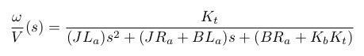

Same transfer function divided by *s.*

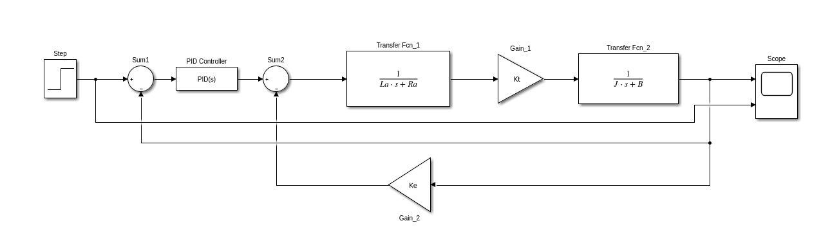SIMULINK model of the above transfer function will be as follows –

In our case normal PID controller will be replace by Fuzzy PID controller

1. **Fuzzy Based Controller**

There are three type of Fuzzy Controllers - Pure Fuzzy Controller, Hybrid Fuzzy Controller and Self Tuning PID Constants with Fuzzy Logic. In first case only fuzzy logic is used and output voltage is generated based on error and change in error only. Hybrid Fuzzy Controller uses a switch which changes its position from pure fuzzy to pure PID controller according to the input error. Self-Tuning Fuzzy Logic generates Kp , Ki, Kd constants which act as input to PID controller i.e., some sort of dynamic constants. Last one is widely used due to its adaptive nature and best results. So in our case too we will use that only.

1. **Motor Parameters Chosen**

Following parameters are chosen from a research paper explaining self-tuning fuzzy logic.

|  |  |  |
| --- | --- | --- |
| **Parameter** | **Value (in model)** | **Description** |
| Moment of Inertia of Rotor (J) | 0.0220 kg-m^2 | Measure of rotor’s resistance to change in rotation rate. |
| Damping Friction (B) | 2e-4 N-m-s | Measure of dynamic friction |
| Torque Constant (Kt) | 0.5 N-m/Amp | Determines motor’s required current for a given torque output |
| Back emf constant (Ke) | 0.5 V/rad/sec | Change in voltage per unit change in angular speed |
| Stator Resistance (R) | 0.450 ohm | Per phase stator Resistance. Used in calculation of power dissipated |
| Armature Inductance (La) | 0.0350 H | Per phase stator inductances. Determines time required to switch on motor meaning time required for current to flow in circuit |

Final SIMULINK Model –

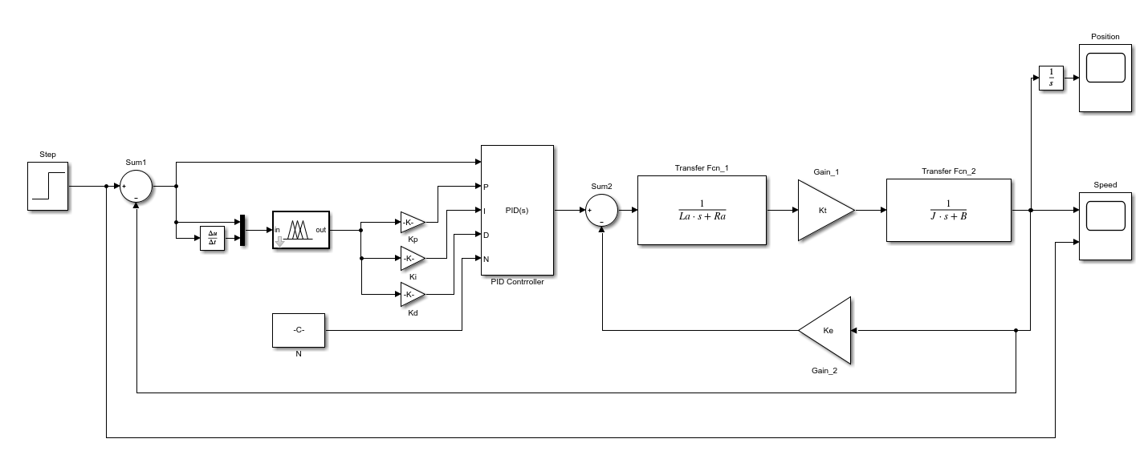

Following Logic was used while designing system –

1. First, the error is taken as input to the controller marked as e. Similarly another input is created , i.e., rate of change of error, ∆e. For both the inputs triangular membership functions were used to characterize the fuzzy sets N (Negative), Z (Zero), and P (Positive).
2. This allows us to have optimum results for the system when input is between the specified range(in this case -1 to 1).

Membership function for both the inputs is depicted as follows –

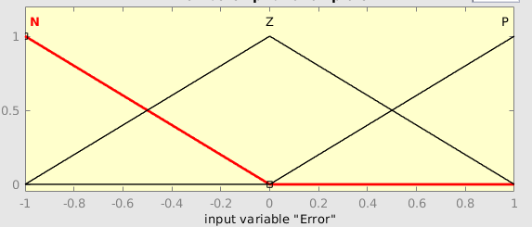

Membership function for output is as follows –

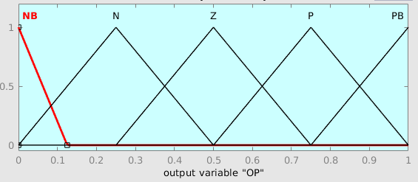

1. It can be seen easily that in our case each output will be limited to -1 to 1. Now with help of simple linear equations we can scale our output to whatever range we want like this –

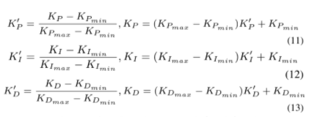

Where Ki’, Kd’ and Kp’ are gains put at output of fuzzy controller. Ki,Kd,Kp will be the final outputs which are acting as an input to the PID controllers.

In our case Kp’, Ki’ and Kd’ are as follows –

Kp’ Ki’ Kd’ = [5.965 200.888 0.551]

1. Rules used for mapping input to output is as follows –

|  |  |  |  |
| --- | --- | --- | --- |
| Error\Change of error | N | Z | P |
| N | NB | N | Z |
| Z | N | Z | P |
| P | Z | P | PB |

Output Surface generated

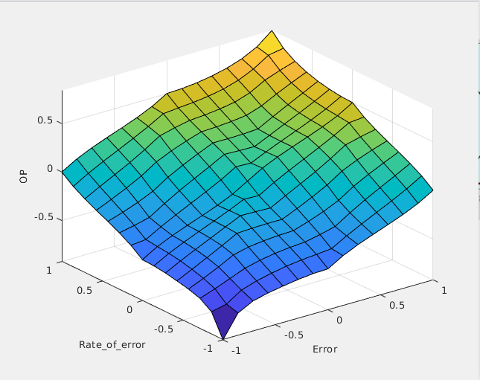

**Results**

**Speed Controller –**

**Blue is step input and Red is speed output controlled by fuzzy logic**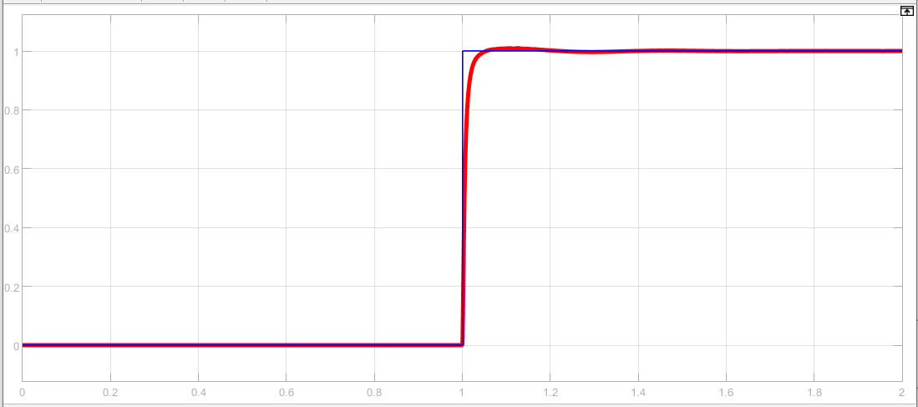

**Characteristics -**

Rise Time – 0.055

Peak – 1.009

Overshoot – 0.9%

Settling Time – 0.037

**Position Output with respect to the above graph –**

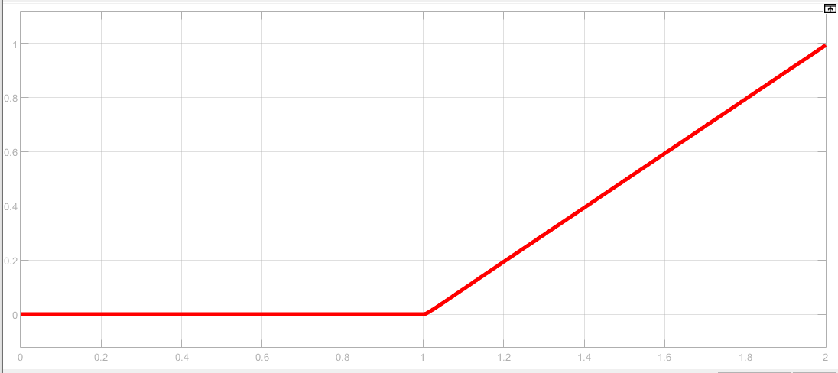

**Position Controller –**

By modifying the Simulink diagram as follows we can have Position control as well –

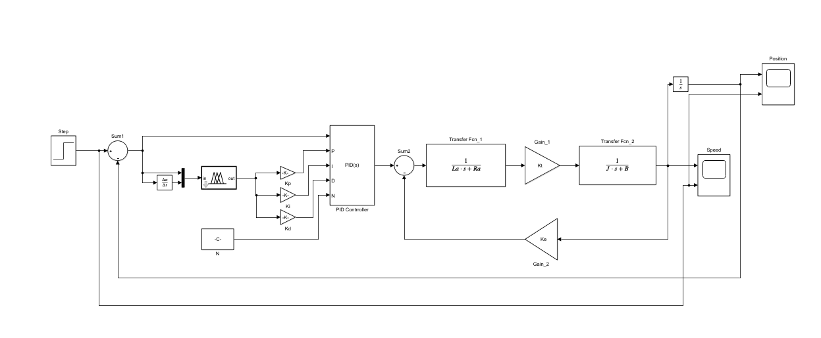

In this case -

[Kp’ Ki’ Kd’] = [1.012 0.412 -0.131]

**Position Controller Output**

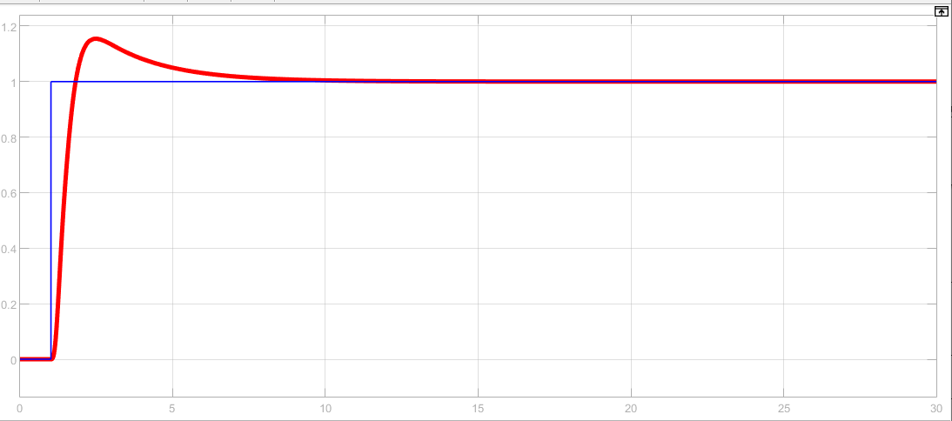

**Characteristics -**

Rise Time - 0.511s

Settling Time – 5.86

Overshoot – 15.5%

Peak – 1.15

**Speed Output with Respect to above graph –**

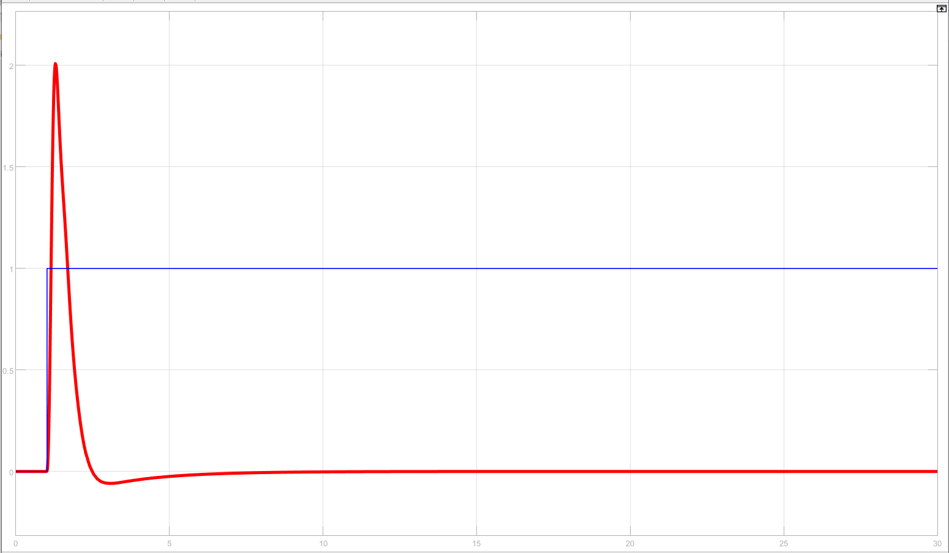

Basically after position is settled speed should be zero